**Drizly Case**

Prof.: - Hossein Abouee Mehrizi

1. Comparison among Retailers
2. 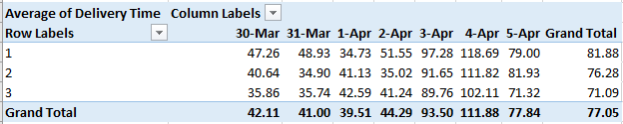 Calculate the average delivery time for each retailer on each day. Is there a difference in the average delivery time between retailers? Test your hypothesis statistically.

Exhibit A.1

* The table above shows Average Delivery time of each retailer on each day.

**T-test for delivery time of Retailers**

**H0 = Average delivery time for Retailers in consideration are equal**

**H1 = Average delivery time for Retailers in consideration are not equal**

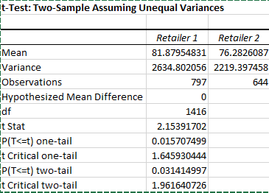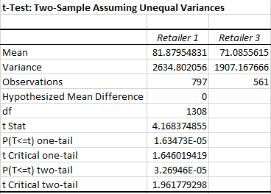

Exhibit A.2 Exhibit A.3

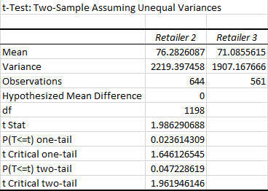

Exhibit A.4

* Exhibit A.2, A.3 and A.4 are results of T- tests with unequal variances conducted on average delivery time of each retailer with other retailers.
* From Exhibit A.2, the difference in average delivery time between Retailer 1 and Retailer 2 is nearly significant.
* Similarly, From Exhibit A.4, the difference in average delivery time between Retailer 2 and Retailer 3 is nearly significant.
* From Exhibit A.3, the difference in average delivery time between Retailer 1 and Retailer 3 is significant. So, we reject the null hypothesis Ho= The average delivery time for Retailer 1 and Retailer 3 are equal.

**One-way ANOVA for delivery time of Retailers**

**H0 = Average delivery time for Retailers in are equal**

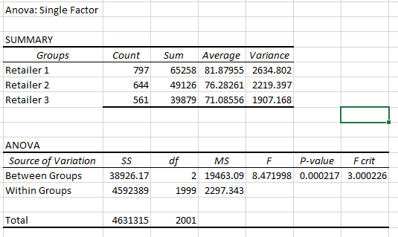**H1 = Average delivery time for Retailers in are not equal**

Exhibit A.5

* Exhibit A.5 shows one way ANOVA comparing delivery time for 3 retailers. From Exhibit A.5, P-value is less than α=0.05. So, we can conclude that delivery time of retailers are significantly different.
* The results from either t-test or ANOVA can be used to reject null hypothesis. Results from ANOVA are significant and can be used to reject null hypothesis.

1. Conduct a similar analysis to part 1 for the void rate.

|  |  |  |  |  |  |  |  |
| --- | --- | --- | --- | --- | --- | --- | --- |
| **Row Labels** | **Sunday** | **Monday** | **Tuesday** | **Wednesday** | **Thursday** | **Friday** | **Saturday** |
| Void rates for Retailer 1 | 12.50% | 6.67% | 4.17% | 0.00% | 4.08% | 18.41% | 20.73% |
| Void rates for Retailer 2 | 13.01% | 6.45% | 0.00% | 4.62% | 3.64% | 15.92% | 23.22% |
| Void rates for Retailer 3 | 16.39% | 4.35% | 4.17% | 6.90% | 4.55% | 17.89% | 20.53% |

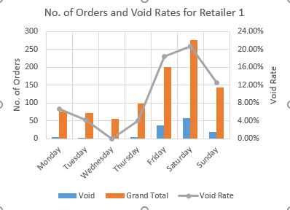Exhibit B.1

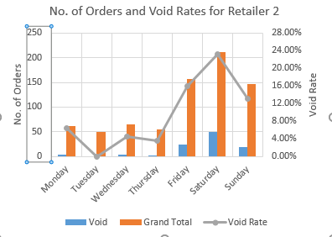

Exhibit B.2 Exhibit B.3

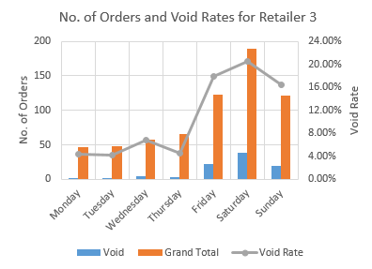

Exhibit 8.4

* Exhibit B.1 shows void rate for each retailer on each day.
* For e.g., Void Rate of Retailer 2 on Wednesday is 0.0462.
* Exhibit B.2, B.3 and B.4 is visual representation of No. of orders (Primary Y-axis) (Delivered and void) and void rate (Secondary Y-axis).

**T-test for comparing avg. GMV delivered and void orders for each retailer**

**H0 = Avg. of GMV of delivered orders and void orders for Retailer in consideration are equal.**

**H1 = Avg. of GMV of delivered orders is greater than that of void orders for Retailer in consideration.**

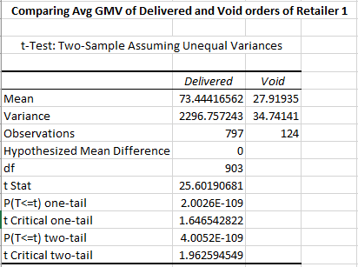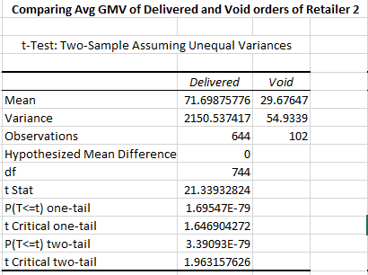

Exhibit B.5 Exhibit B.6

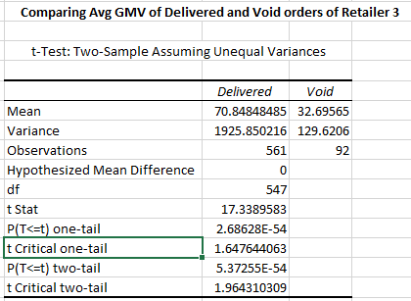

Exhibit B.7

* Exhibit B.5, B.6 and B.7 shows t tests performed between avg. GMV of delivered and void orders for retailer 1, retailer 2 and retailer 3 respectively.
* Observing P-values of the one tailed t tests, we can reject null hypothesis. We can conclude average GMV of delivered orders is higher than average GMV of void orders.

**T-test for comparing void rates between retailers**

**H0 = Average void rates for Retailers in consideration are equal**

**H1 = Average void rates for Retailers in consideration are not equal**

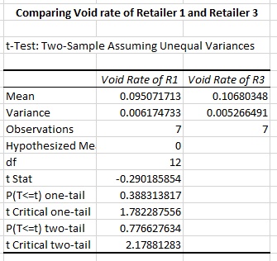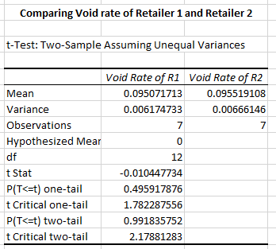

Exhibit B.8 Exhibit B.9

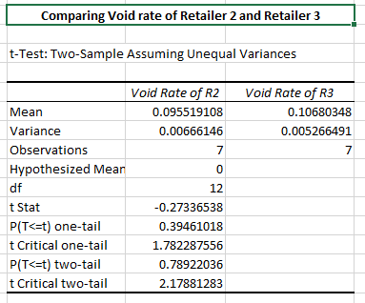

Exhibit B.10

* Exhibit B.8, B.9 and B.10 shows t tests for void rates of retailer 1, retailer 2 and retailer 3.
* Observing P-values, we cannot reject H0 at α = 0.05 significance level. Additionally, one point that should be noted is that the sample size is very small and can have significant impact on the conclusions.

**ANOVA for comparing void rates between retailers**

**H0 = Average void rates for Retailers are equal**

**H1 = Average void rates for Retailers are not equal**

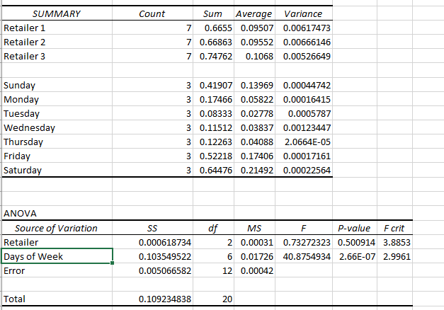

Exhibit B.11

* Exhibit B.11 shows ANOVA table comparing void rates of retailers.
* The results from ANOVA table shows that, as P-value for retailers is 0.5, we cannot reject null hypothesis. So, the void rates are not different for retailers.

**T-test for comparing avg. GMV of void orders of 2 retailer at a time**

**H0 = Avg. of GMV of void orders for Retailers in consideration are equal.**

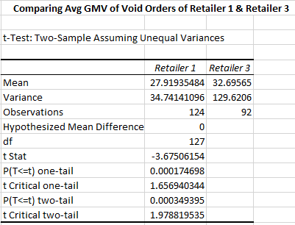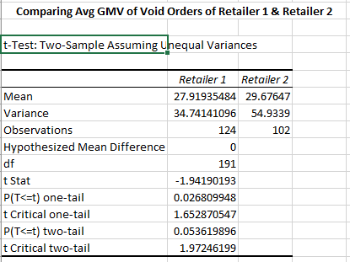 **H1 = Avg. of GMV of void orders for Retailers in consideration are not equal.**

Exhibit B.12 Exhibit B.13

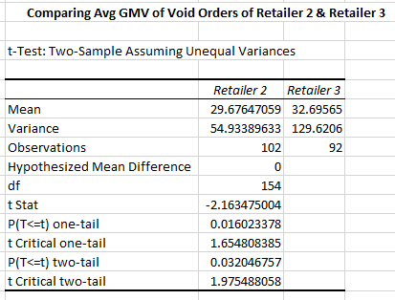

Exhibit B.14

* Exhibit B.12, B.13 and B.14 shows t test between average of GMV of void orders of the retailers in consideration. We can decisively reject H0 for comparison of avg. GMV of void orders of retailer 1 and 3.
* T tests conducted regarding void rates and void order, one possibility can be that retailers may have same void rates (Exhibit 8.8, 8.9, 8.10 and 8.11) but they might have decided not to fulfill orders having GMV below certain threshold (Exhibit 8.5, 8.6 and 8.7) and the threshold can be same or different for each retailer (Exhibit 8.12, 8.13 and 8.14).

**Chi squared test (Contingency Table) for relation between retailer and order status**

**H0 = Retailer and order are independent**

**H1 = Retailer and order are not independent**

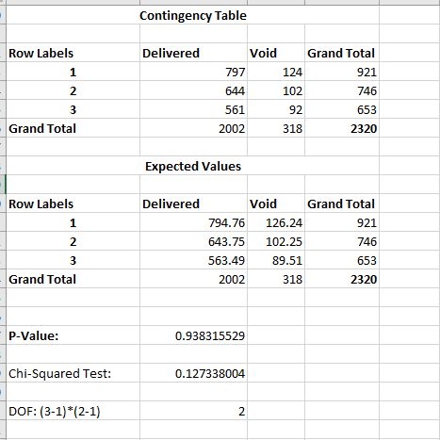

Exhibit B.14

* Exhibit B.14 shows the result of chi-squared test on dependency between retailer and order status.
* From the P-value, we cannot reject H0. We can deduce that there is no relationship between retailers s

|  |  |  |  |
| --- | --- | --- | --- |
|  | Retailer 1 | Retailer 2 | Retailer 3 |
| Void rate for orders<=$35 GMV on weekdays | 15.58% | 16.36% | 15.69% |
| Void rate for orders<=$35 GMV on weekends | 62.66% | 60.16% | 57.58% |
| Void rate for orders>$35 GMV on weekdays | 0.00% | 0.00% | 1.80% |
| Void rate for orders>$35 GMV on weekends | 2.81% | 4.15% | 7.14% |

Exhibit B.15

* Exhibit B.15 depicts void rates on weekdays and weekends for orders having GMV <=35 and GMV<35.
* From above exhibit, we can observe that void rates for order having GMV<=$35 is very high compared to void rate for orders having >35 on weekends.
* Also, nearly no orders with GMV>35 is void on weekdays but around 15% of orders having GMV<=35 is voided.

1. Based on the last two parts and the total GMV of each retailer, is there any significant difference between retailers?

* Total GMV of Retailers
* Exhibit C. shows total GMV of retailers over a week. It is clearly observable that retailer 1 has the highest total GMV followed by retailer 2 with retailer 3 having the lowest total GMV among the three retailers.

**Conclusions**

* Average delivery time of retailer 3 is lowest followed by retailer 2. Retailer 1 has highest average delivery time amongst these retailers. Average delivery time for retailers are different (ANOVA results)
* Average delivery time all the retailers is around 45 mins on weekdays which shoots up between the range of 90 to 120 mins on weekends.
* Average GMV of void orders for retailer 3 is slightly higher than retailer 1 which is shown in t test exhibit B.12 whereas Avg GMV of void orders for retailer 2 is slightly higher than retailer 1 which is shown in t test results of exhibit B.11 which is nearly significant at α = 0.05 significance level.
* Average GMV of delivered order is significantly higher than average GMV of void order for all the retailers.
* T test was performed to compare void rates of retailers and the which shows that the void rates of all the retailer is same. But the reliability is questionable as the sample size is very small.
* The void rates for order having GMV<=$35 (around 60%) is very high compared to void rate for orders having >35 (around 15%) on weekends.
* Also, nearly none of the orders with GMV>35 is void on weekdays but around 15% of orders having GMV<=35 is voided.
* One of the possibilities can be that retailers intentionally skip orders having GMV lesser than certain threshold which maybe less profitable. Also, around 15% for orders having GMV<=35 is voided whereas nearly none of the orders were voided for GMV>35 on weekdays which can lead to one more possibility that retailers don’t fulfill orders below certain as the profit margin can be nearly none or even loss on certain orders.
* Total GMV over the week of retailer 1 is highest and total GMV over the week of retailer 3 is lowest.

1. Create 3-hour time intervals (starting from 12:00 PM) for April 3rd, April 4th, and April 5th.
2. Visually show how the total GMV and number of orders change during these time intervals.

Exhibit 2A.1

|  |  |  |  |
| --- | --- | --- | --- |
| Row Labels | No. of Orders | Total GMV | Avg. GMV |
| 12:00 PM - 03:00 PM | 175 | 10975 | 62.7143 |
| 03:00 PM - 06:00 PM | 646 | 41516 | 64.2663 |
| 06:00 PM - 09:00 PM | 748 | 49319 | 65.9345 |

Exhibit 2A.2

1. Do you think the total GMV and number of orders are different across different time intervals? In which time interval are they higher?

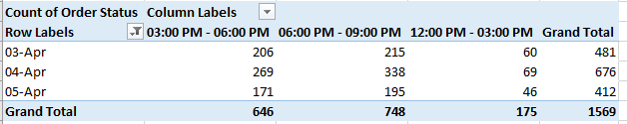

Exhibit 2B.1

**ANOVA for no. of orders in 3 hr time interval**

**H0 = No. of orders in 3 hr interval are same.**

**H1 = No. of orders in 3 hr interval are not same.**

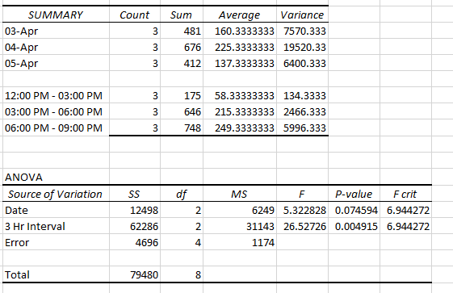

Exhibit 2B.2

* Exhibit 2A.1 shows graphically total GMV and no. of orders in three 3 hours intervals starting from 12 PM.
* Exhibit 2A.2 shows total GMV and total no. of orders in 3 hr interval from 3rd Apr to 5th Apr.
* It is clearly observable that total GMV and no. of orders are highest in 06:00 PM – 09:00 PM interval and lowest in 12:00PM – 03:00 PM interval. But average GMV remains same in all three intervals
* Exhibit 2B.2 shows ANOVA table for comparison of no. of orders in 3 hrs interval. From the table, we can observe that P-value= 0.004915. So, we reject null hypothesis at α=0.05 significance level and conclude that no. of orders in 3 hr interval are different.

1. How could Drizly management use this analysis and make informed decisions?

* Analysis from average delivery time shows that average delivery time shoots to around 90 mins on weekends.
* Drizly can

1. can help retailers get more drivers for peak times
2. Increase delivery time expectation
3. Encourage retailers to use 3rd party delivery services

* As void rates are significantly higher for orders having GMV<=$35 on weekends for all the retailers.
* Drizly can

1. Recruit more retailers
2. Increase minimum GMV/order
3. Penalize retailers for voiding lower GMV orders and also try to compensate if an order fulfillment can lead to loss to the retailer

* No. of orders increases in between 03:00 PM to 09:00 PM which is more prevalent on weekends.
* Drizly can

1. Dynamic Pricing (Higher Prices in this interval)
2. Set capacity limits per hour
3. Increase delivery fee
4. Shift demand to early in day by offering coupons
5. Discount on orders if ordered on weekdays